**Manifest Upload Table Editing**

Overview

Data translation and validation is driven by data tables found in the PBIApplicationTables database on the WEBAPPS server. This document will explain how to edit the various tables. For validation purposes the data for Famous validation table is updated daily by a job running on the database server. The following is a list what is updated from Famous: Commodity, Variety, Style, Size, Grade, Label and Pallet Type. The following dropdowns are also updated at the same time: Warehouse, Grower, Region and storage.

Update all Famous Values

To update all famous validation values for the tables select Update From Famous on the tools menu. This will get all the data needed for the dropdowns and validation of the Famous uploads from the Famous application database and up the tables used by the Manifest Upload application.

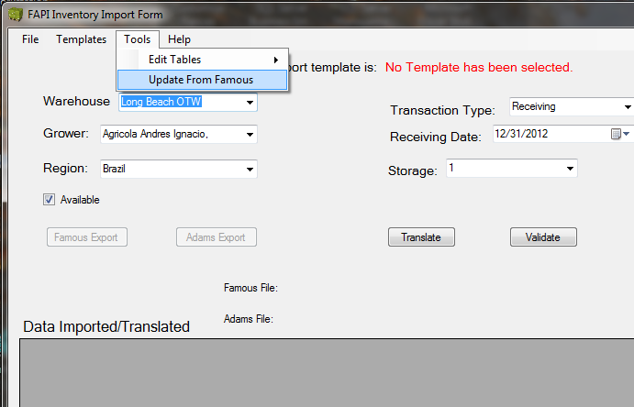

Edit Translation Validation Table

Select Tools/Edit Tables/Translation_Validation to bring up the editor for the Famous Translation and Validation table.

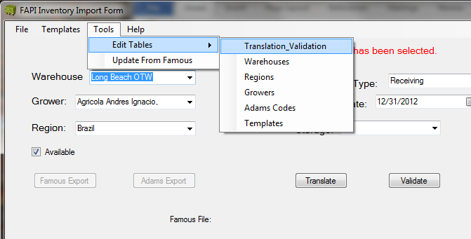

When the Editor Window opens, select the parameter to be edited. There is an option to show only values where the Adams value is missing. This will be helpful if all that is needed is to add an Adams value to the translation of a Famous value.

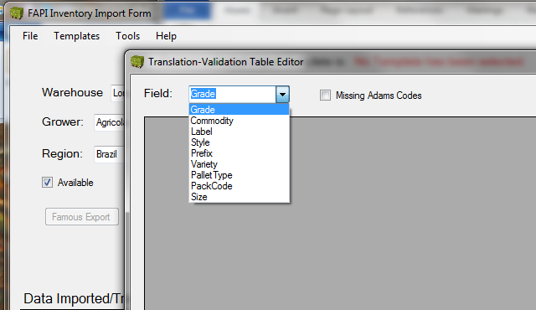

Grade

Selecting Grade will bring up the Translation and Validation data for the grade parameter. These values are used to Translate manifest upload spreadsheet Grade codes to the Famous Grade codes and to validate them. Translation for Adams export is done in a separate table which will be discussed later in this document. If an Adams value was used in the spreadsheet then it will be looked up in the Adams_Value column to find the Famous Value. The program will search both description and Adams Values to find a match for the translation to Famous codes.

Here is an example.

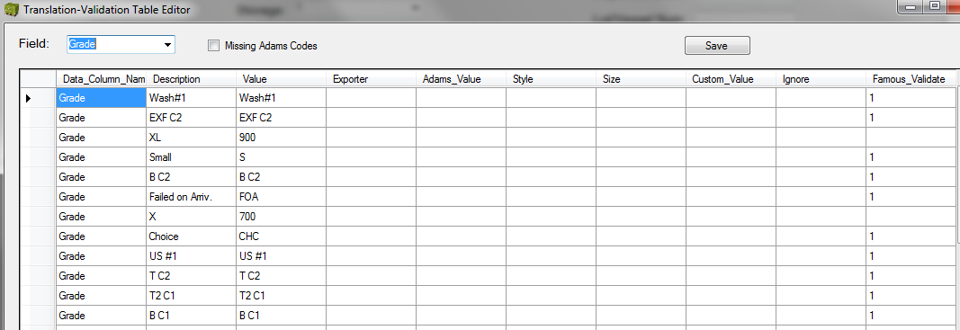

Ordering of the data in the data view can be done by clicking on the column name. This can be useful for finding specific values. DO NOT EDIT any entries which have a “1” in the famous Validate column. If you do the famous validation will not validate correctly. If you do run the Update From Famous tool to reupdate all famous values. In fact this would be good practice to do after any editing of the validation table.

To edit an existing Grade value, find the row of a non-Famous_Validate value (one without a 1 in the Famous Validate column). For example,

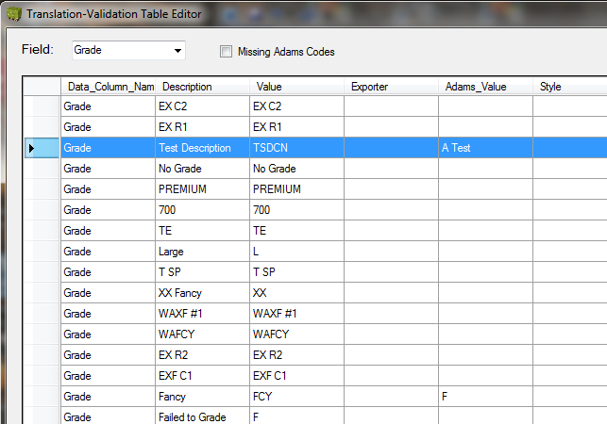

The one highlighted above (Test Description). In this example we are going to change the Adams value from “A Test” to “AT”. To do that, double click the cell for the Adams_Value and select the text “A Test.” Then type in the new value “AT.” When this completed, press <Return> and click the <Save> button a the top of the edit form. With is change, if an exporters manifest spreadsheet has a value of “AT” in the Grade column, it will be translated to “TSDCN.”

To add a new Grade translation go to the bottom of the data edit table and being entering the new data beginning with the Data_Column_Name cell. Click twice on the first cell of the last row to begin entering data. For the Data_Column_Name, enter “Grade” and click the <Tab> button to go to the next cell.

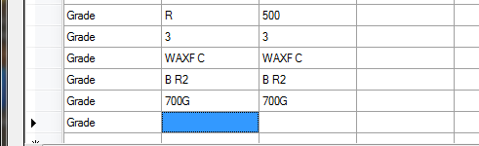

Enter the Description as it will be in a manifest upload spreadsheet that will come from an exporter. Let’s for this example say they will be sending fruit with the code “Extra Good” which translates to grade 700 in Famous codes. Enter “Extra Good” into the description column, press the <Tab> key and then enter “700” into the Value column. If there is new Adams code that also translates to the “700” grade in Famous, then it can be entered into the Adams_Value column after clicking the <tab> key twice, otherwise just click <Enter> key and click the <Save> button at the top of the form.

To delete a grade translation, select the row to be deleted by clicking on the left end of the row, click the <Delete> key and then click the <Save> button at the top of the edit form.

Commodity

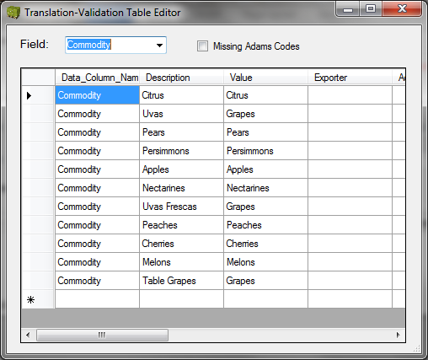

To edit the Commodity list, select Commodity from the dropdown list of the Translation-Validation Editor form. Descriptions and values can be edited, added or deleted like for the Grades above. Again, DO NOT EDIT any entries with a 1 in the Famous_Validate column and run the Update From Famous tool when done. This translation table, translates commodity description or code that may be in an incoming manifest upload spreadsheet into famous code. As can be seen the image below it will translate the Spanish “Uvas” into “Grapes” during the translation process for any spreadsheet that us that as a commodity. Currently there is no difference between Famous and Adams codes, so no Adams translation is needed.

Label

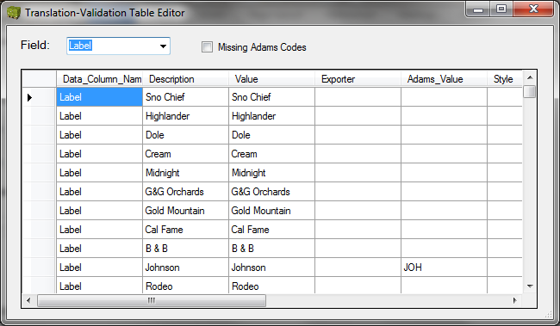

Editing the label translation again is the same as for Grades. And also the warning DO NOT EDIT entries with a “1” in the Famous_Validate column. And run the Update From Famous tool when done with all editing and saving. Adams uses different codes than Famous, so find and enter the Adams code when available at the same time if an exporter uses them in their export manifest spreadsheets. . Translation for Adams export is done in a separate table which will be discussed later in this document.

Style

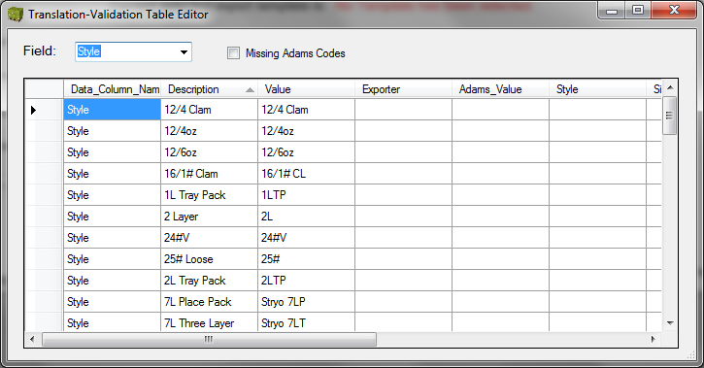

Selecting Style will bring up the Translation and Validation data for the Style parameter. These values are used to Translate manifest upload spreadsheet Style codes to the Famous Style codes and to validate them. Adams uses Pack Codes so no translation is necessary for Style. Translation to Style from a pack code is done in the Pack Code translation, which will be covered later.

And also the warning DO NOT EDIT entries with a “1” in the Famous_Validate column. And run the Update From Famous tool when done with all editing and saving.

Size

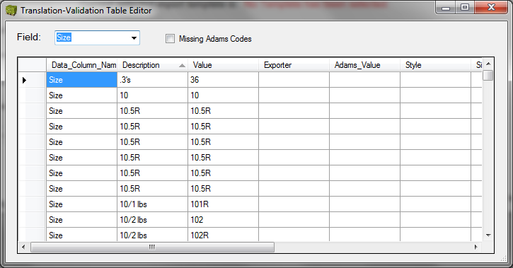

Selecting Size will bring up the Translation and Validation data for the Size parameter. These values are used to Translate manifest upload spreadsheet Size codes to the Famous Size codes and to validate them. Adams uses Pack Codes so no translation is necessary for Size. Translation to Size from a pack code is done in the Pack Code translation, which will be covered later.

And also the warning DO NOT EDIT entries with a “1” in the Famous_Validate column. And run the Update From Famous tool when done with all editing and saving.

Pack Code

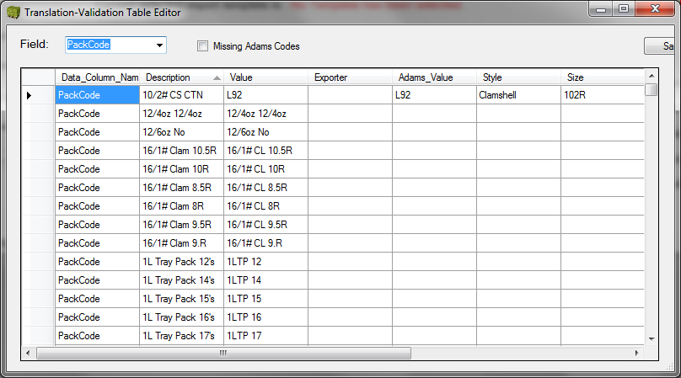

Selecting Pack Code will bring up the Translation and Validation data for the Pack Code parameter. These values are used to Translate manifest upload spreadsheet Pack Code codes to the Famous Style and Size codes, which are then validated (Pack Codes are not validated). Entering the Adams codes are necessary to translate from Adams codes into Famous Style and Size, so always add the Adams values when available. Also entering the Adams Pack Codes here provides a handy reference to lookup the translations if needed.

And also the warning DO NOT EDIT entries with a “1” in the Famous_Validate column. And run the Update From Famous tool when done with all editing and saving.

Pallet Type

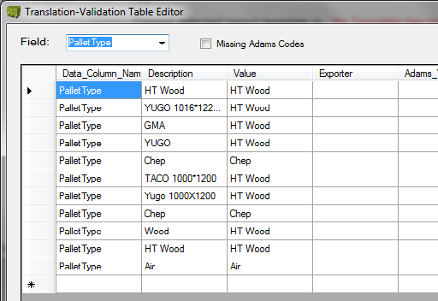

Selecting Pallet Type will bring up the Translation and Validation data for the Pallet Type parameter. These values are used to Translate manifest upload spreadsheet Pallet Type codes to the Famous Pallet Type codes and to validate them. Adams does not use Pallet Type code so no values are needed for Adams.

Note: When entering “PalletType” for the Data_Column_Name for new entries, it is one word without a space between Pallet and Type.

And also the warning DO NOT EDIT entries with a “1” in the Famous_Validate column. And run the Update From Famous tool when done with all editing and saving.

Prefix Codes

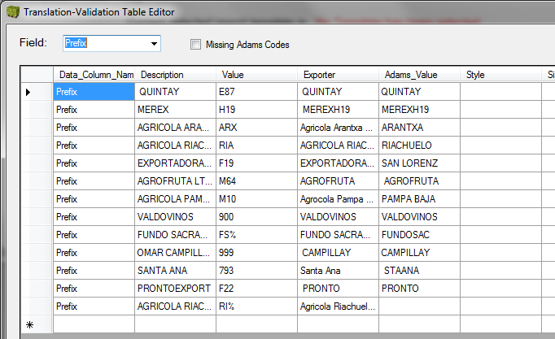

Selecting Prefix will bring up the Translation and Validation data for the Prefix parameter. These values are used to add the exporter name to the archive that is used for reports given a prefix code or Adams name for the exporter. These should be updated as new prefixes are found or arrive.

Run the Update From Famous tool when done with all editing and saving.

Edit Adams Codes

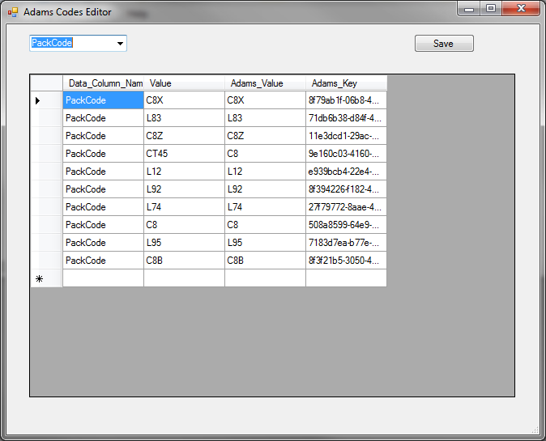

Pack Code

This table is used to translate both existing codes and codes that were created for missing pack codes. If a manifest upload sheet has only Style and Size, but not pack codes, the application will create a pack code column and populate it with a pack code created from the translated Style and size for each pallet entry. It will be of the form Style, space, Size and you will have to add the translation to this table. For a Carton and a size of 8KB, the entry will look like the one below. If the Adams export does not translate the pack code correctly check this translation table and verify that the translation for the pack code is present.

You must enter the word “PackCode” (No Space) in the first column of all entries. Leave the last column blank.

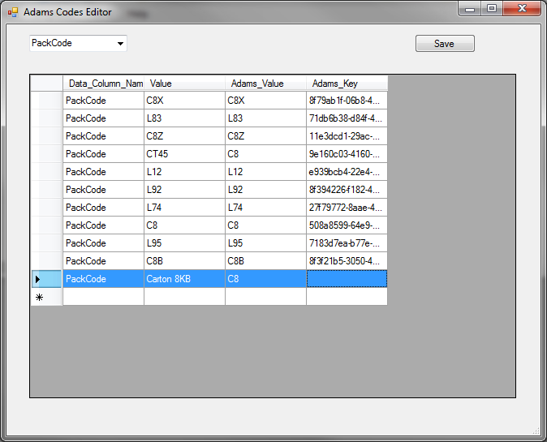

Press the <Enter> key and click on the <Save> button when done with the changes.

Grade

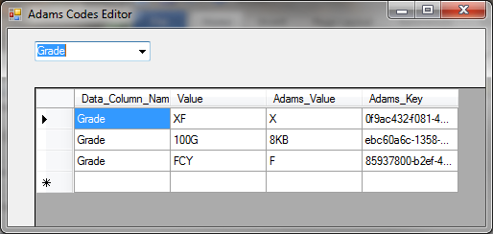

This table allows custom translations to be used during translation. You must enter the word “Grade” in the first column of all entries. Leave the last column blank.

Press the <Enter> key and click on the <Save> button when done with the changes.

Label

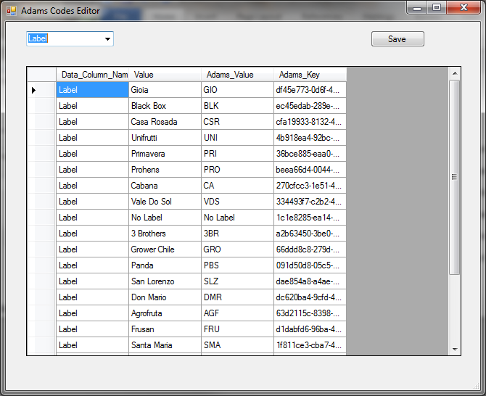

All labels must be translated to Adams values for export to Adams. Check and verify that all the labels in the manifest translate correctly. If not then enter the Famous value and Adams Values into this table.

You must enter the word “Label” in the first column of all entries. Leave the last column blank.

Press the <Enter> key and click on the <Save> button when done with the changes.

Variety

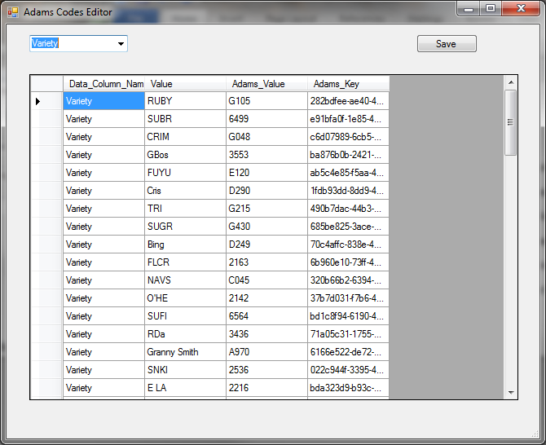

For proper translation from the Famous to the Adams variety codes, verify that the translation entries are in this table. If not then add them, putting “Variety” in the first column, then the famous variety code and finally the Adams code.

You must enter the word “Variety” in the first column of all entries. Leave the last column blank.

Press the <Enter> key and click on the <Save> button when done with the changes.

Prefix Codes

The Prefix Code table is not used to translate prefix codes as they are already in Adams format. It is there as a reference only and should be updated as needed to have a handy and available reference.

Edit Warehouse List

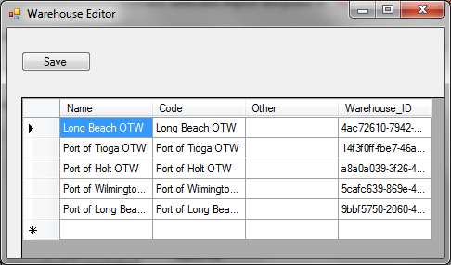

Selecting Tools/Edit Tables/Warehouse will bring up the Warehouse Editor Window. This allows the warehouse list to be edited. It is not recommended that these be edited as only Famous values are allowed and they are edited with Update From Famous tool.

And also the warning DO NOT EDIT entries with a “1” in the Famous_Validate column. And run the Update From Famous tool when done with all editing and saving.

Regions

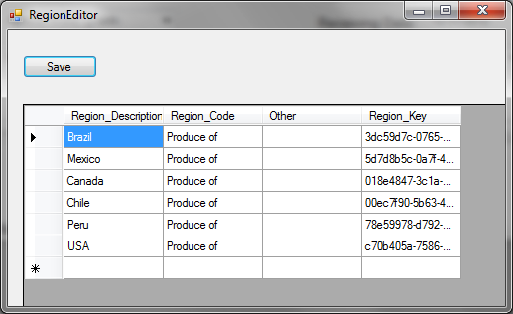

Selecting Tools/Edit Tables/Regions will bring up the Region Editor Window. This allows the warehouse list to be edited. It is not recommended that these be edited as only Famous values are allowed and they are edited with Update From Famous tool.

And also the warning DO NOT EDIT entries with a “1” in the Famous_Validate column. And run the Update From Famous tool when done with all editing and saving.

Growers

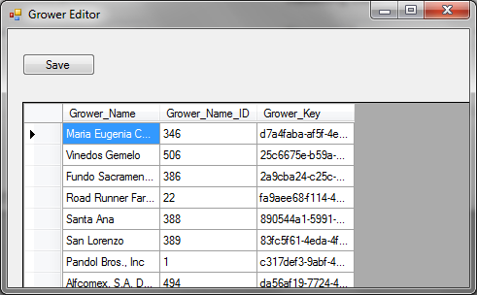

Selecting Tools/Edit Tables/Growers will bring up the Grower and Grower number Editor Window. This allows the warehouse list to be edited. It is strongly not recommended that these be edited as only Famous values are allowed and they are edited with Update From Famous tool.

And also the warning DO NOT EDIT entries with a “1” in the Famous_Validate column. And run the Update From Famous tool when done with all editing and saving.

Template Table Editing

Instructions for creating templates are found in the Creating Templates document and with the help of the Template worksheet.xlsx has directions for creating or modify existing templates.